2.15 Week Trading thoughts

**Monday:**

did not long. 2823 was at a -14.89% discount by the end of Friday. 3147 was at a staggering -7% (rose 11% in 2 days). 2822,3147 was also at a -4% discount. This was too much.

Currently, indices are either on the verge of or already have broken the 20 DMA. The strong performance on Monday:

br if weekday == 1 & retOPC<-0.025 yields 5 results, 4 are bear market, 1 is bullmarket.

br if weekday == 1 & retOPC<-0.025 & retCO >0.02, yielding one result which is bull market. The strength of the recovery is a characteristic of the bull market.

By this point, it was logically deducible the market has entered into a different phase which was different from that of the pre-CNY period.

**Tuesday:**

shorted too early (exited the position with no damage but was painful holding through it). Market peaked out at around 13:15. Short position was entered at 10. Conditional distribution of the max at 10:15 was:



(hist amMaxT1 if weekday ==2 & amMaxT1>10.25 & (amMinT1<9.75 | amMinT1>10.25), percent width(0.25) start(9.5) addl)

Distribution of day's maxT at noon: (43% of the max being after 2). If it is Monday, then this figure would be 64%. It was a risky bet, and the entrance point was not good (impatient).



amMinT1<9.75

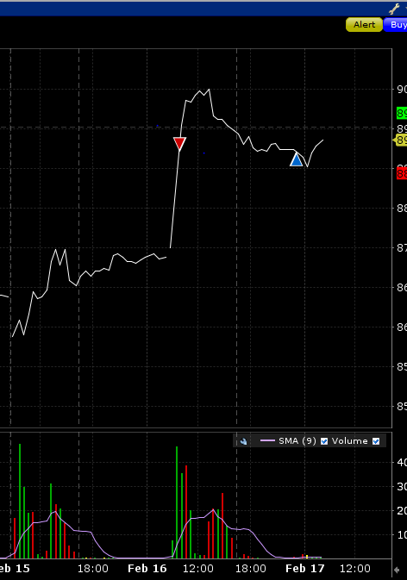

**Wed:**

Didn't trade today. Bull market characteristics continue to demonstrate. Afternoon session was very strong. All indices bounced to close at day high. Low point occurred at noon. Research results today include that for 25% of days, 000001 will close within the top 10%, but only 13% will close within the bottom 10%. The systematic bullish nature of the index dictates that being long should be the predominant method to trade, unless market circumstances are distinctively bearish, as characterized by a statistically significant margin below 20DMA.

As was felt by close of day on Monday, the rebound on Monday was bullish and signified that things had clearly changed. The strength of the moves today also show the same. Bullish position needs to be put on and held. This Friday and next Monday are important to test the significance of the bull market.

XU is not convinced day's close and P/D went to -1.2%. I would like to pick up some position here but the level is not attractive enough. Tomorrow there is a chance of a retreat and fri and next Monday I am making the assumption that should be reasonably bullish.

Cuing @ 8932.5, attractive discount here. Today in late morning was an attractive entrance point given the assumption of the bull market.

After second thought, I will buy on thurs, it is more comfortable that way. And hold through the weekend.

**Thursday:**

Small intraday volatility. The rebound came earlier than expected.

Both max and min were in the morning, this happens 13% of the time.

**Friday:**

Small intraday volatility. Went long in the morning. There was a few opportunities to cash in on the opportunity. Market panicked into the close and all the gains were wiped out. In low-volatility scenarios such as today, directionless moves are predominant and need to take profit when appropriate while trading.

Next week's position:

Since the Friday's return is negative, decided to cut position and wait on Monday for opportunities. Closed out the position at +0.2%.

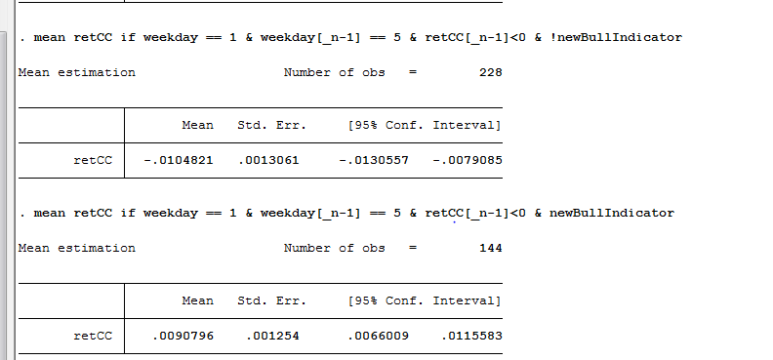

If today was reasonably strong, I would have carried the position over to next Monday. Given the weak market sentiment today, cutting position was deemed to be optimal.

Today's main takeaway was in times of low market volatility, buying and holding will underperform an active trading strategy. Take some profits off the table when market is moving in one's favor. Leave a remainder of the position but staying stoic with the whole size on is neither flexible nor optimal.

Weekly recap:

Monday opened -3%. The strength of the rebound was unusual. Historically only 1 day had such low retOPC and managed to close almost flat. A bull weak was established accordingly. After an assuring Monday, Tuesday saw a rally world-wide. CNXT in US up 10%. ASHS up 8%. Massive discounts were reduced to almost nil. Wednesday to Friday saw reduced volatility with volatilities crashing down. Investors are obviously still recovering from the horrendous January, and are being very cautious in trading.

Trading issues:

Tuesday's shorting was problematic in the sense that the short position was put on prematurely. After the establishment of the bull market along with the need for a rebound after an atrocious January, investors were looking to have a retaliating rally. Upon perusing the curve this week, several thoughts proceed as follows. On Wednesday, for the drop in the morning session (with the discount descending to -1.3%ish), could put on position at this point. By EOD Wednesday, the discount descended to -1.2% (as detailed above in the daily recap), cuing at 8932.5 but did not persist with the order. Thursday morning the chance to short when the opening level was above the highest point of Wednesday. Thursday, traditionally being a non-strong day, was a good target for shorting.

Specific trade types that need careful consideration:

Trading at the open: this is based on the opening level which should significantly differ from previous day's trading range. The rationale is that two days overlap 95% of the time.

Trading at midday: A buy trade at midday at the then lowest level is more beneficially then selling at the then highest level just by the fact that a rebound in the former scenario is more likely than a crash in the second scenario, especially in bull market.

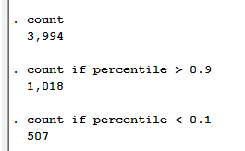Insight1: The diagram on the left shows that for 25% of total days, the market will close in the 90% percentile but only for 12% of the days it will close in the bottom 10% percentile.

In Bull Market: 34% will end up near day's highs and 6% will end near day's lows.

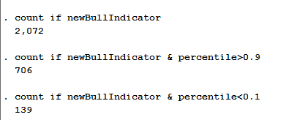

In Bear market: (newBullIndicator !=1): 16% will end near day's highs and 19% will end near day's lows.

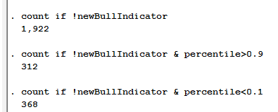

The above analysis demonstrates that it is a better idea to buy at a lower percentile than to sell at a higher percentile in general (unless it is bear market). A co-requisite being when the discount supports rather than discredits the trade.

Potential issues: 1. after entering a position at the lows, when to the cut the position if it keeps dropping? Will there be an averaging low? Proposed solution: first, if it is a bear market scenario, entering the trade should be done on day's end instead of day's mid. Second, if it is a bull market scenario, then such position should be entered when discount is suitable and there can be a additional position at the close.

Trading at specific times: this needs to be based on the discount/premium and absolute advantage of the level.

